Emotional and Mental Health Wellbeing Audit
The Emotional and Mental Health Wellbeing Audit (below) has been written to help you review your current approach to Emotional and Mental Health, allowing you to identify strengths and areas for development. The following audit is based upon the eight principles of the whole school approach as laid out in the document ‘Promoting children’s and young people’s health and wellbeing – a whole school and college approach’ published by Public Health England and the children and young people’s Mental Health Coalition March 2015. It would be useful to view this document whilst completing the audit.
Schools can consider the descriptors and record how they are currently meeting them. The self- assessed ‘RAG’ (red, amber or green) rating helps to identify which areas need more attention in developing a whole school approach.
Schools can then use the action plan template at the end of the audit to plan ‘next steps’.
AREA OF WHOLE SCHOOL APPROACH |  |  | CURRENT POSITION |  |  |  |  | RAG RATING
 |  |  |  |  |  |  |  | R | A | G
1. Leadership and management that supports and champions efforts to promote emotional health and wellbeing
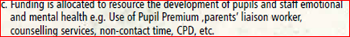
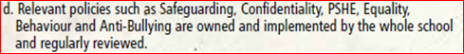
2. School ethos and environment that promotes respect and values diversity
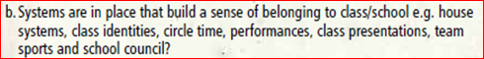
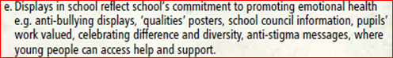
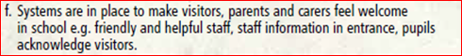
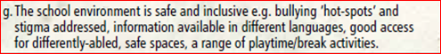
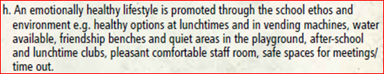
3. Curriculum, teaching and learning to promote resilience and support social and emotional learning.
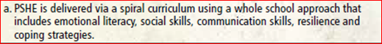
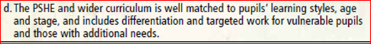
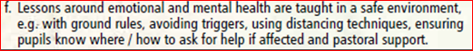
4. Enabling pupil voice to influence decisions
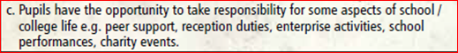
5. Staff development to help their own wellbeing and that of pupils
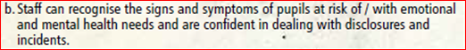
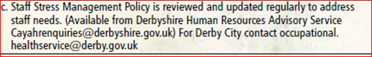
6. Identifying need and monitoring the impact of interventions
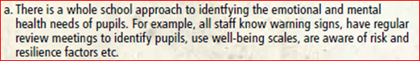
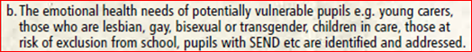
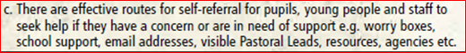
7. Working with Parents and Carers
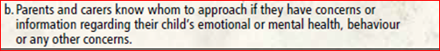
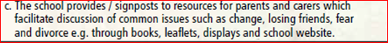
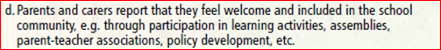
8. Targeted support and appropriate referral
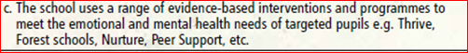
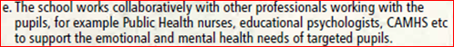
Emotional and Mental Health Whole School Action Plan
Area e.g. 1a | What do you want to achieve? | Actions |  | Who? | When by? | How will you measure the impact? | Achieved

